**ASSIGNMENT 8**

**AIM: -**

Implement aggregation and indexing with suitable example using MongoDB.

**OBJECTIVE:-**

To implement Aggregation and Indexing using MongoDB.

INPUT:-

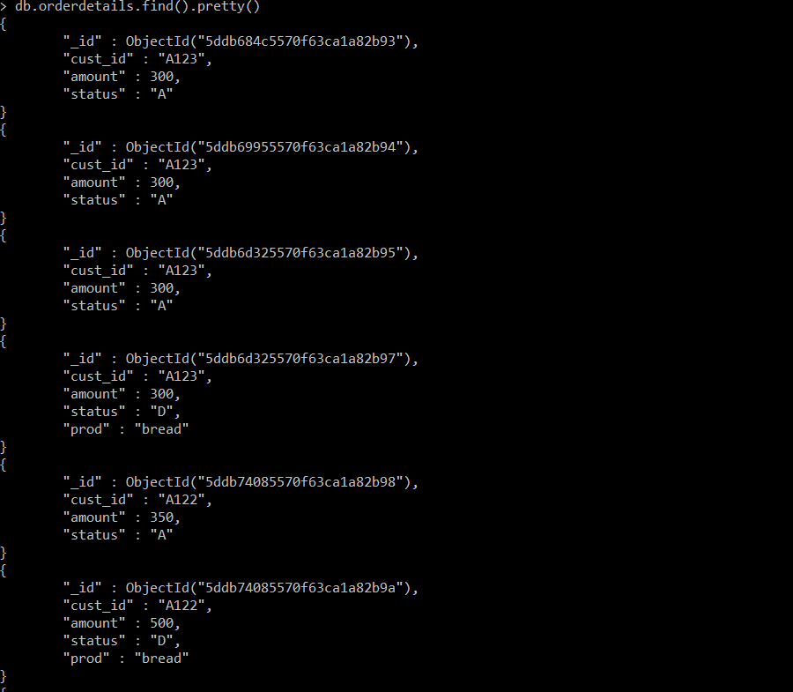

OUTPUT:-

